

**كلية العلوم الحاسوبية والمعلوماتية**

Faculty of CSI

MYFLIX

*Students:*

|  |
| --- |
| Hala Mohammad Omar Ali 202320200 Lana Tala Sabbah 202320442 |

*Supervisor:*

Dr. Omar Akash

*Amman - Jordan*

*2024/2025*

**Table of Contents**

1.1 Problem Statement and project Scope page 1

1.2 Project Plan and Schedule

2. System Analysis page 2

2.1 Functional Requirements

2.2 Use Case Diagram

3. System Design page 3

3.1 Class Diagram

3.2 ER-Diagram (if a database will be used)

3.3 User Interface

* 1. Problem Statement and project Scope

The system has been facing problems due to its paper-based appointment

system. With the increase in the number of patients visiting, it has

become diﬃcult to manage the appointment system manually. Recording

of appointments and creating registers by pen and paper has become a

Problem Statement   
In today’s digital era, users are constantly seeking platforms that allow them to browse, categorize, and save their favorite movies efficiently. While many commercial and feature-rich movie websites exist, these platforms often include unnecessary complexities or require paid subscriptions, which may not suit all users—especially those who seek a simple and personalized movie experience.

There is a growing need for a lightweight and user-friendly movie platform that focuses on core functionality: browsing categorized movies, saving favorites, and offering personalized access. Additionally, administrators should be able to manage movie records through a dedicated and secure control panel.

This project aims to eliminate dependency on large platforms by providing users with a clean, structured, and manageable movie system that offers more control over their interaction with the content.

project Scope

This project involves the development of a responsive and interactive movie website using HTML, CSS, PHP, and MySQL. The system supports two types of users:

Users: Can register, log in, browse movies by genre, and add or remove movies from their personal favorites list.

Administrators: Have access to a secure dashboard where they can add, edit, or delete movie records.

All data is stored in a structured MySQL database, which includes tables for users, movies, and favorite movies. The interface is designed to be clean, intuitive, and easy to navigate.

This project lays the foundation for a simple movie platform prototype. Future enhancements could include features like movie ratings, user reviews, and integration with external APIs to fetch real-time movie data.

* 1. Project Plan and Schedule

Project Plan  
The project will be developed in structured phases to ensure organized progress and timely delivery. Each phase has clear objectives and deliverables to ensure the final product meets all functional and technical requirements.

Project Phases:

1. Requirement Gathering & Analysis

Define system requirements and user expectations.

Identify core functional features for both users and admins.

Analyze similar systems to understand best practices.

2. Design

Create wireframes and UI layout sketches.

Design user interface using HTML and CSS.

Develop the database schema and ER diagram.

3. Development

Front-end development using HTML and CSS.

Back-end development using PHP.

Integrate the MySQL database.

Implement user authentication and movie management functionality.

4. Testing

Perform full functional testing and UI validation.

Identify and fix bugs.

Ensure smooth user interactions and correct database operations.

5. Deployment

Finalize the system and ensure all features are stable.

Host the application locally (via XAMPP) or on a live server if needed.

Prepare and complete project documentation.

Figure 1: Gantt Chart of project

2. System Analysis

2.1 Functional Requirements

The system is designed to meet the needs of two main types of users: regular users and administrators. Below is a breakdown of their core functionalities:

👤 User Functions:

* Register and create a new user account.
* Log in using valid credentials.
* Browse all available movies on the website.
* Filter movies by categories such as Action, Comedy, Drama, etc.
* View basic movie details (title, image, description).
* Add or remove movies from their personal favorites list.
* View a personalized page of favorite movies.

🛠️ Admin Functions:

* Log in using admin credentials.
* Access a secure admin dashboard.
* Add new movies (including title, genre, description, and image).
* Edit details of existing movies.
* Delete movies from the system.
* View and manage all movie records in one place.

2.2 Use Case Diagram

Figure 2: Use Case diagram of system

3. System Design

3.1 Class Diagram

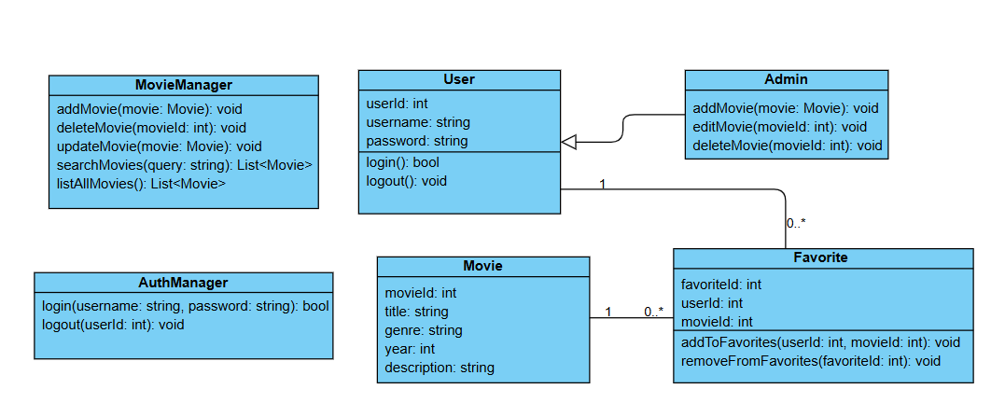

Figure 3: Class diagram of Appointment system

3.2 ER-Diagram

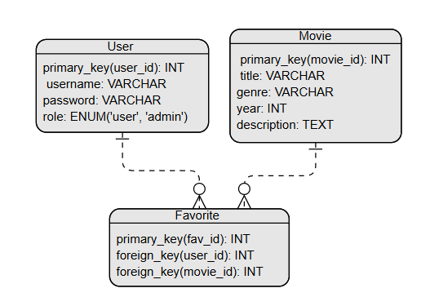

Figure 4: ER diagram of Appointment system

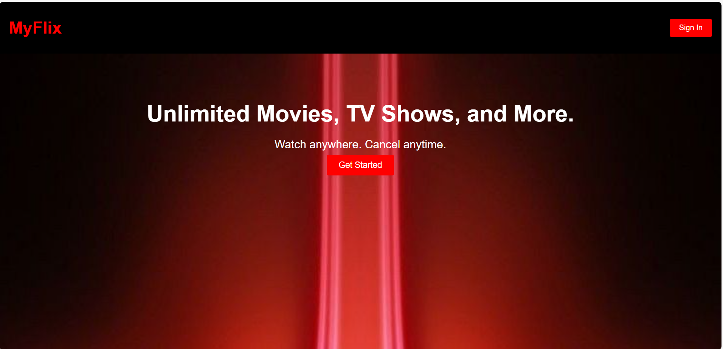

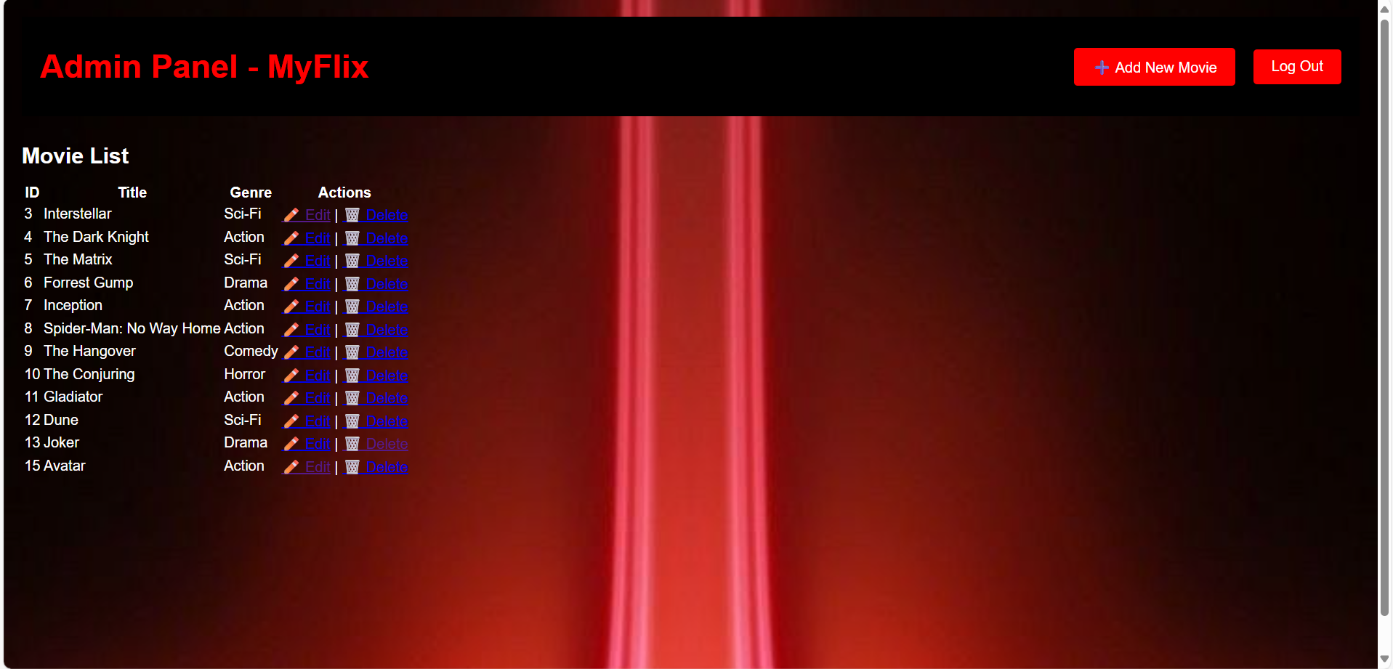

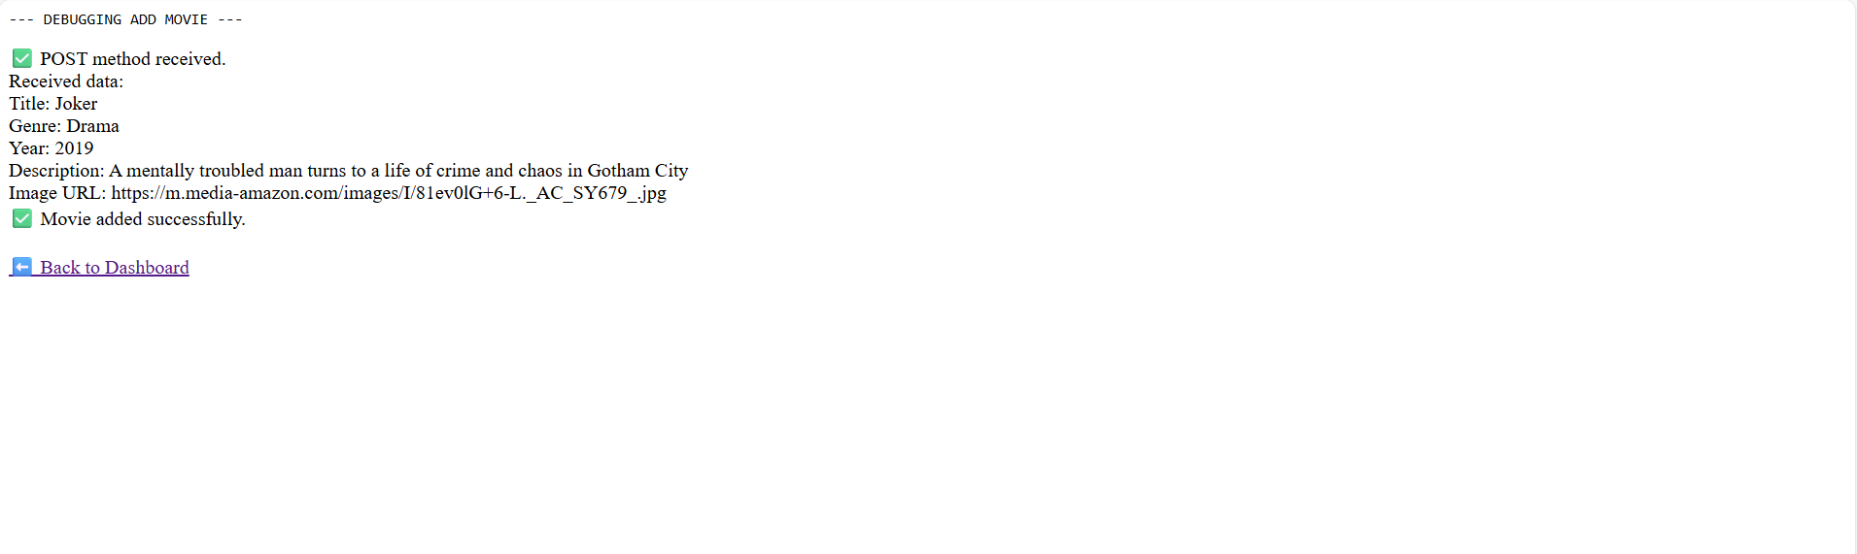

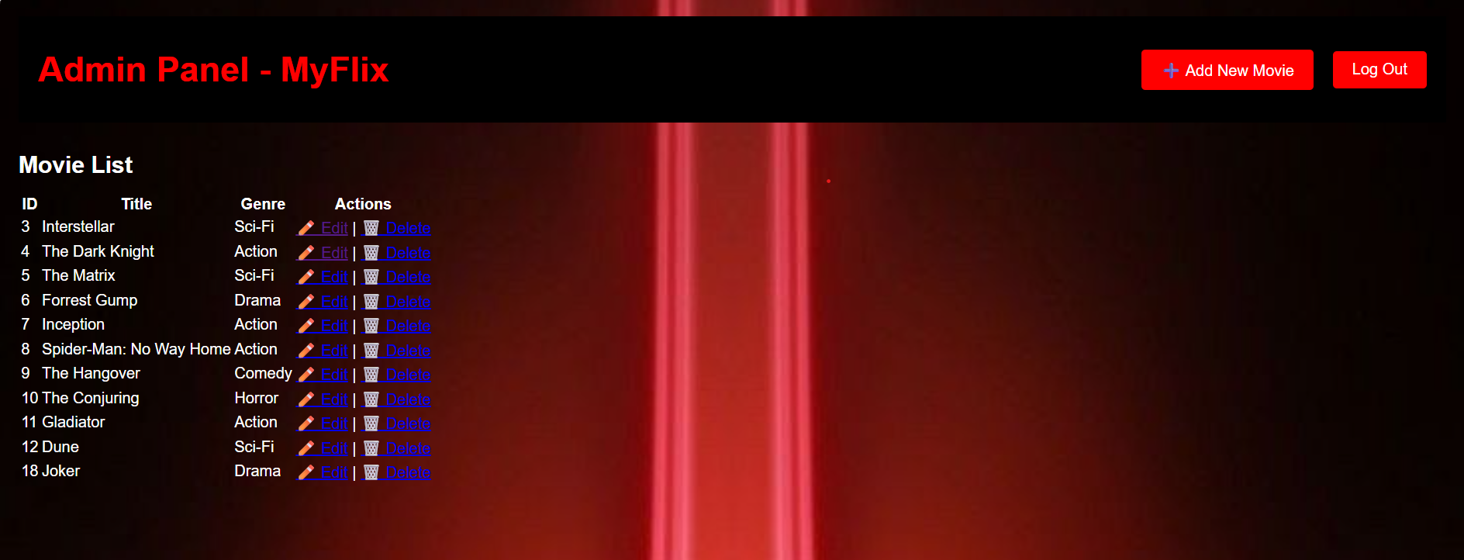

Figure 6: Show All UI of system